Jenkins Assignment 3 using pipeline
Create 3 repository and add index.html in each repository then create 1 pipeline job and write script
So we can see all file in one pipeline job . for ex : http://ip/first http://ip/second like wise

Step 1 – lauch instance and install java 21 then create 1 directory inside mnt like /mnt/server and wget tomcat and unzip then give permission then go to bin and do ./startup.sh then goto webapp and wget Jenkins and do Jenkins setup (must add customTCP in security group with port 8080.)
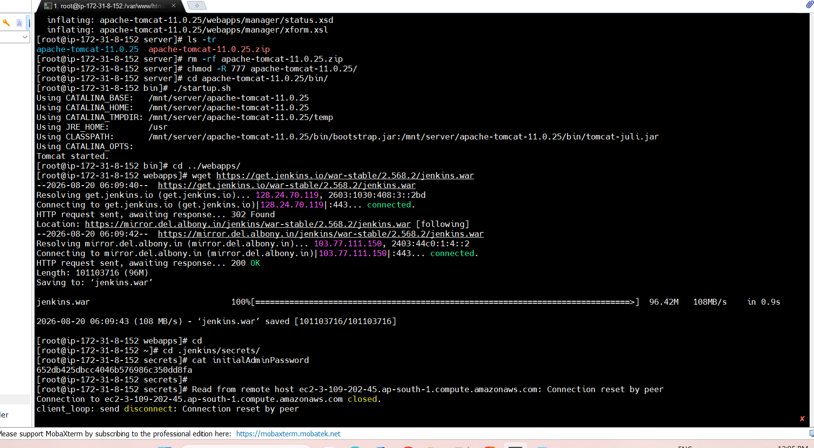
Step 2 goto Jenkins dash board and create 1 pipeline job
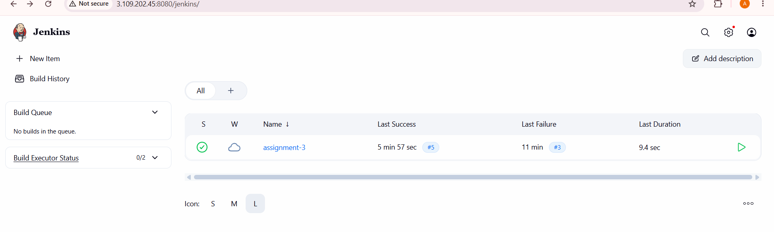
Step 3 in your github create 3 repository like firsr-repo, second-repo.. and add index.html file in each repo
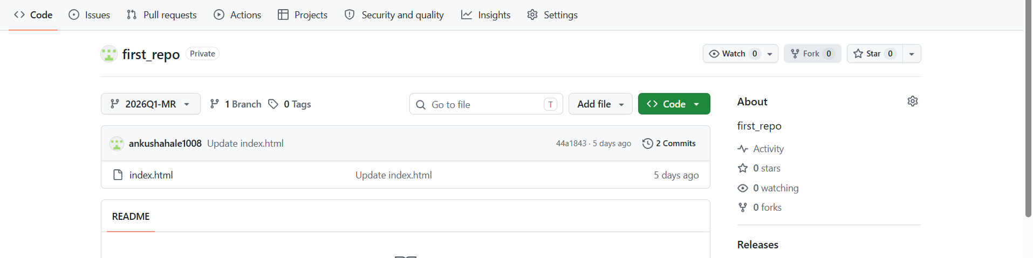

Step 4 then write script and add your job
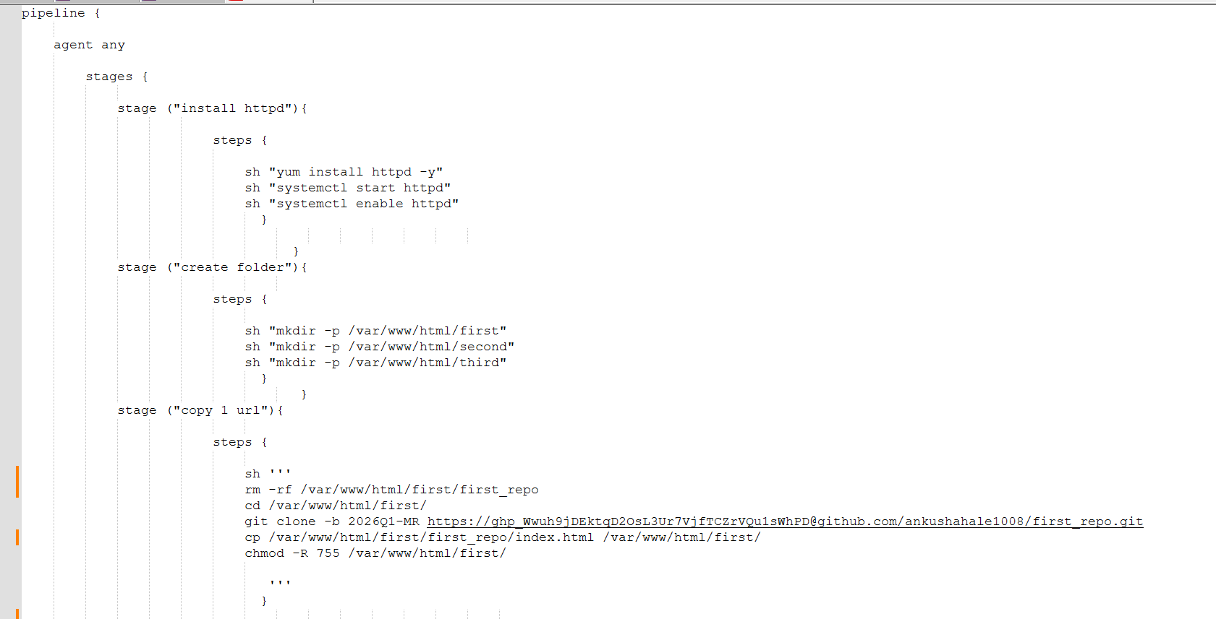
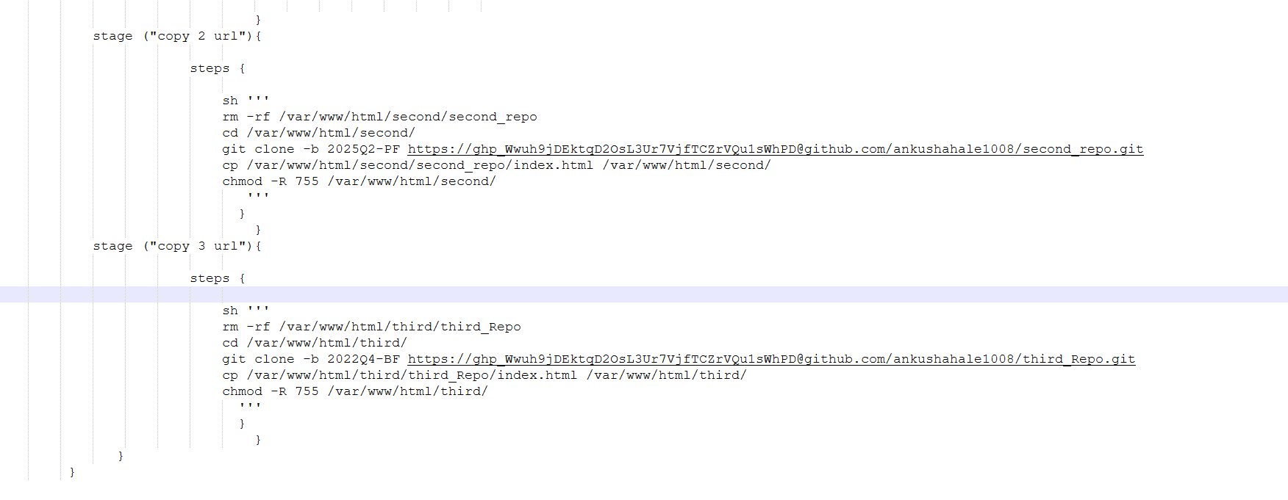
Step 5 click on apply and save then build now
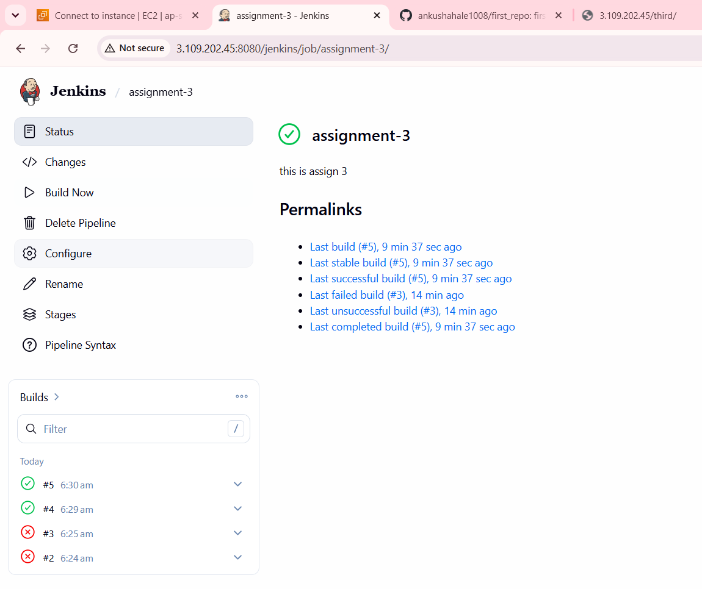
Step 6 – check stages
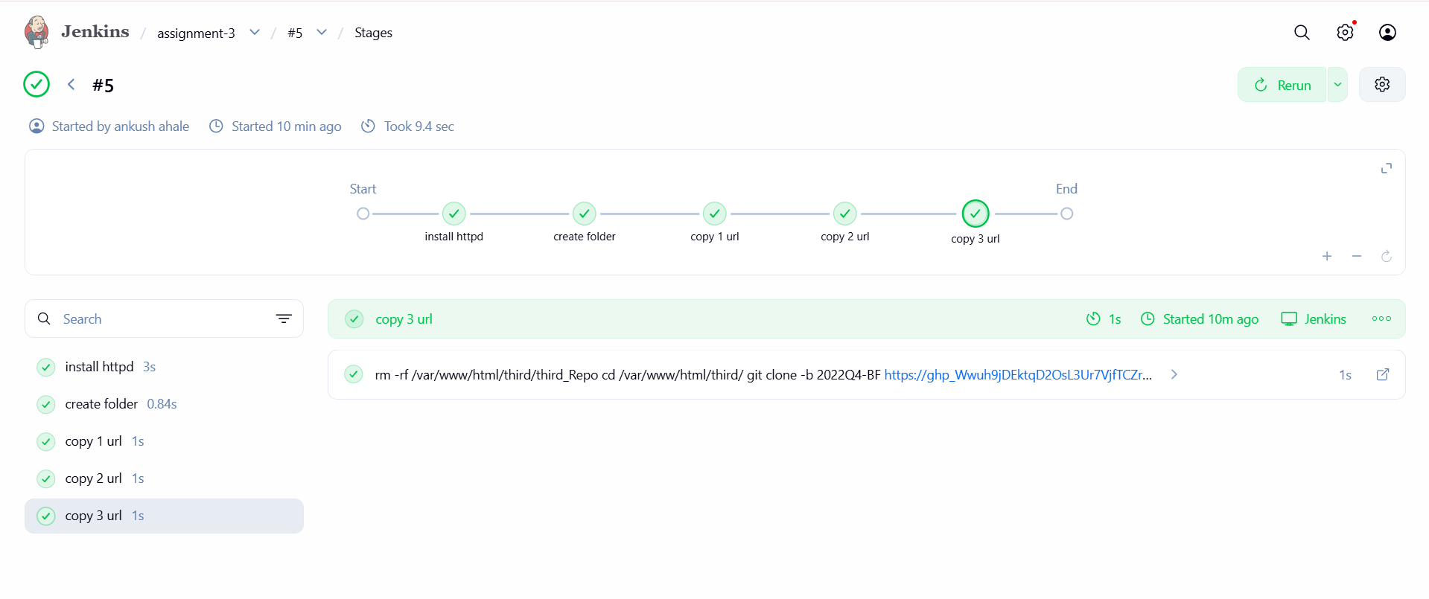
Step 7 – goto url and check for ex http://ip/first, http://ip/second
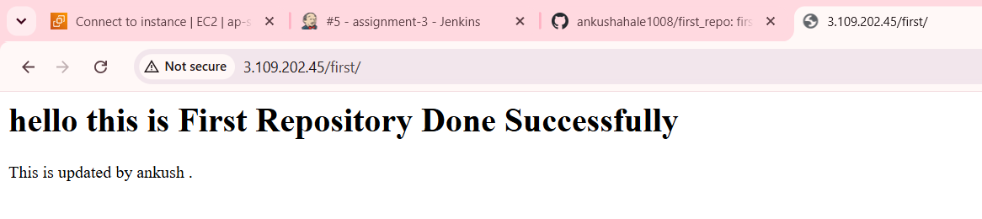
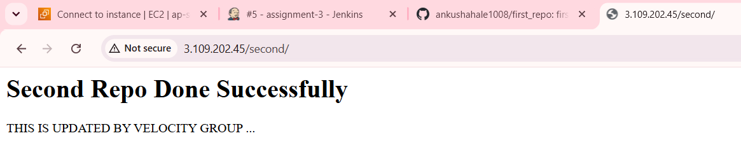
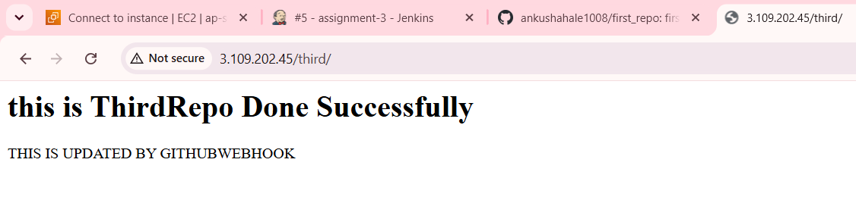
Assignment Done SuccessFully.

